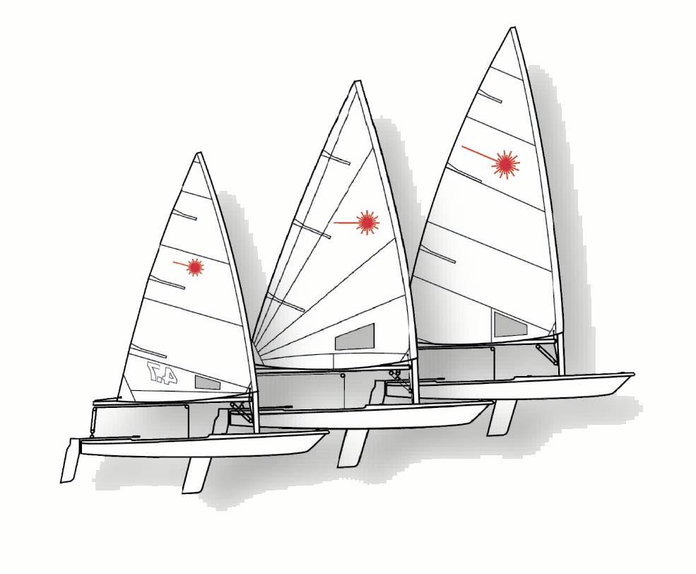
ILCA – European Region

Feedback form:
Boatlength around zone at the mark

Name

Dates and Names of Regattas

Number of Entries

Wind, weather and water conditions

3 boat lengths tested | YES / NO
COMMENTS:

4 boat lengths tested | YES / NO
COMMENTS:

Which boat length would you prefer to be used at European Laser events? |   

ANY OTHER COMMENTS:

PLEASE RETURN VIA EMAIL TO office@laserinternational.org OR FAX TO +44 1326 318968
PLEASE RETURN BY 31st March 2009

